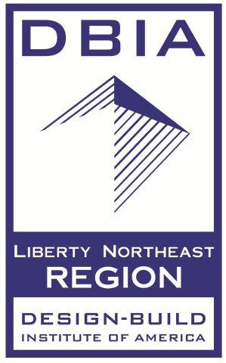

2021 PA-AWWA FIRST VIRTUAL ANNUAL CONFERENCE SCHEDULE - MAY 25-26, 2021

Time Tuesday – May 25, 2021

8:00 am– 9:00am Opening Session – Welcome – Craig Palmer and Jim DeWolfe- PA-AWWA
AWWA Director – Michael Brown – Introduction
AWWA Representative – Richard Hope – Wisconsin Section

Keynote Speakers –More Than Words: Time to take action on diversity & inclusion!
Nicole Brown – AECOM, Associate Vice President
Liesel Gross-CEO, Lehigh County Authority
2021 Baxter and Fuller Awards – Tim Trout, PA-AWWA and Richard Hope, AWWA

9:00am – 12:00pm Track #1 – Cybersecurity and SCADA
Track #2 – Data Management
Track #3 – DBIA Sessions

10:00am -10:30am Break
12:00pm – 1:00pm Lunch Break-PA-AWWA Awards and Visit Vendors

1:00pm – 4:00pm Track #1 Lead and PFAS
Track #2 Pumping Systems
Track #3 DBIA Sessions

2:00 pm – 2:30pm Break
4:00pm – 5:00pm Happy Hour with Vendors– Scribblio Game and Raffles
Poster Contest

Time Wednesday – May 26, 2021

8:00am – 9:00am Opening Session Day 2

Welcome – Craig Palmer and Jim DeWolfe– PA-AWWA
US EPA Update: Patti Kay Wisniewski, US EPA Region 3 (Tentative)
Vendor Time is the Right Time!

9:00am – 12:00pm Track #1 – Utility Management
Track #2 – Water Quality and Treatment
Track #3 – DBIA Sessions and Communication Sessions

10:00am – 10:30am Break-Visit Vendors
12:00pm – 1:00pm Lunch Break – YP Poster Contest, Partnership for Safe Water Awards
and Visit Vendors

1:00pm – 4:00pm Track #1 – Distribution and Storage
Track #2 – Contracting and Construction
Track #3 – DBIA Sessions

2:00pm – 2:30pm Break-Visit Vendors

4:00pm – 5:00pm Happy Hour with Vendors– Raffles and Conference Wrap Up

